Name: Pranali Sonawane
Subject: MCSA
Date: 31-12-2025
Lab 23: NLB(Network Load Balancing)

- In Server 1 and Server 2 Install Network Load Balancing and Web Server
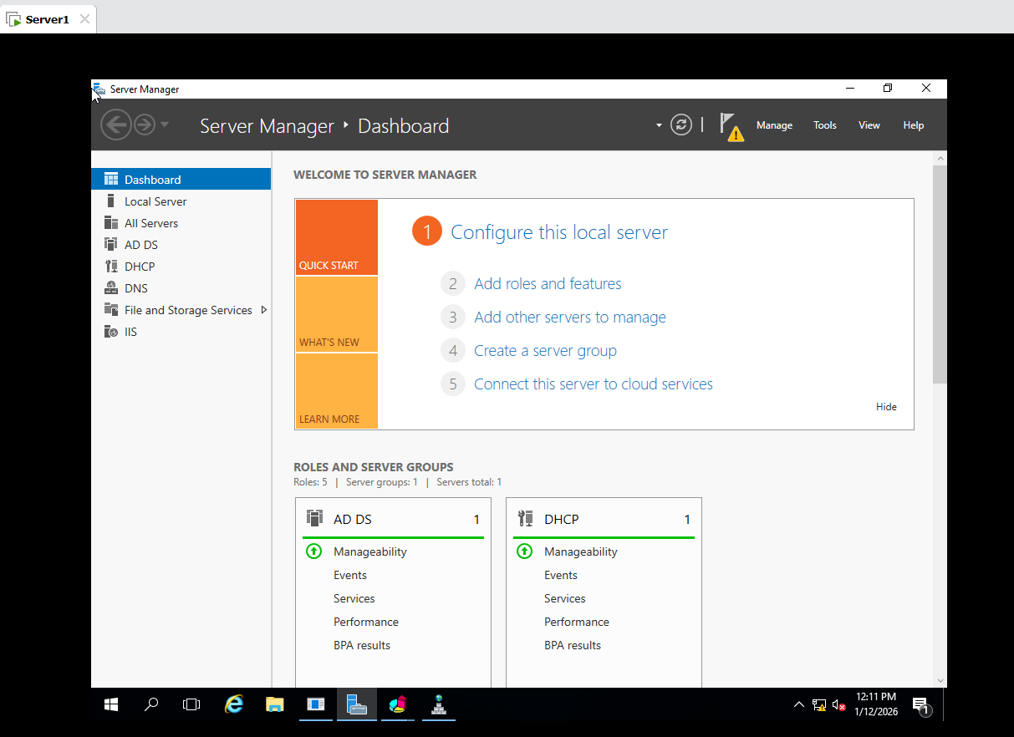
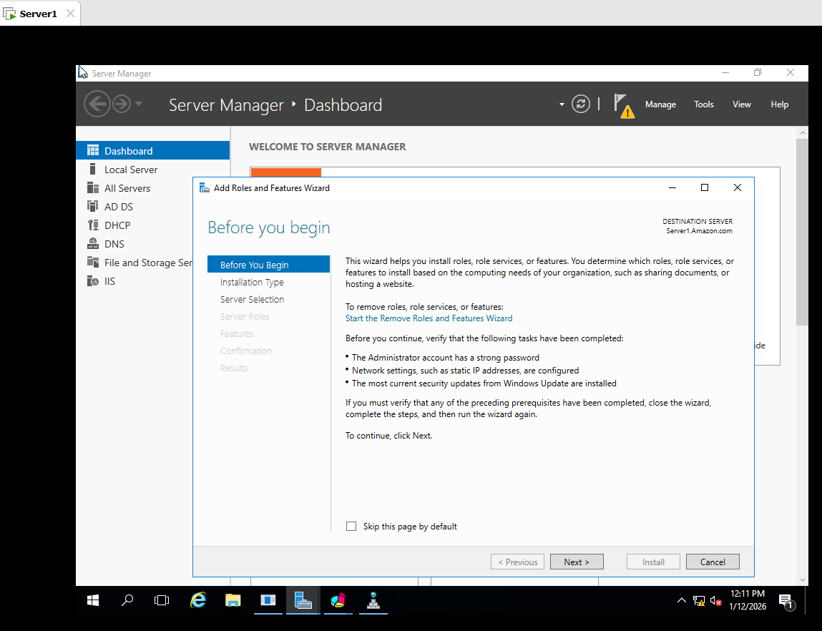
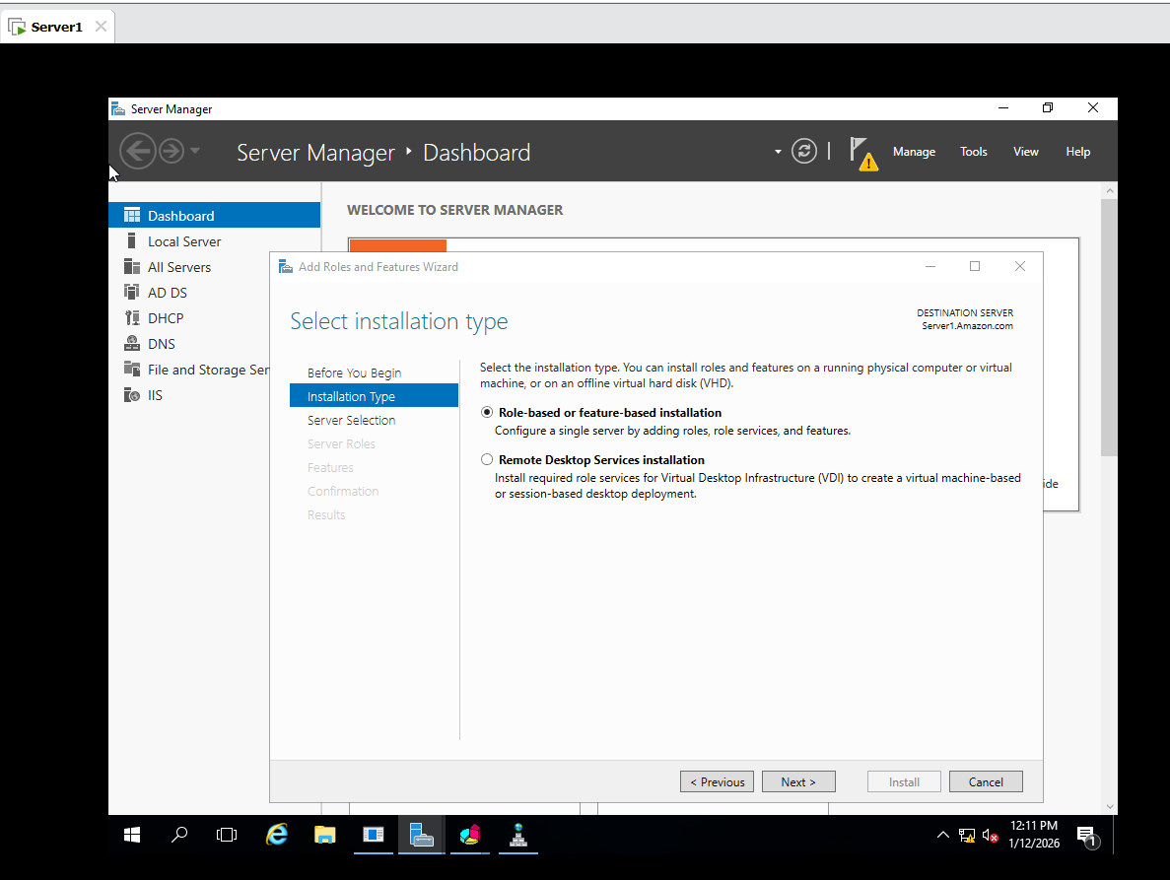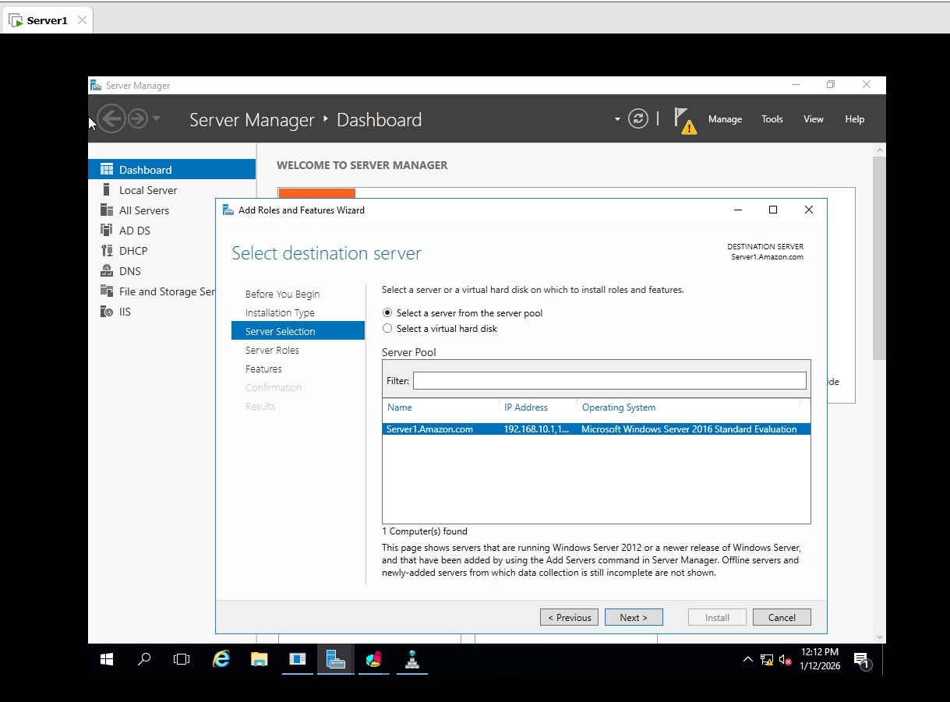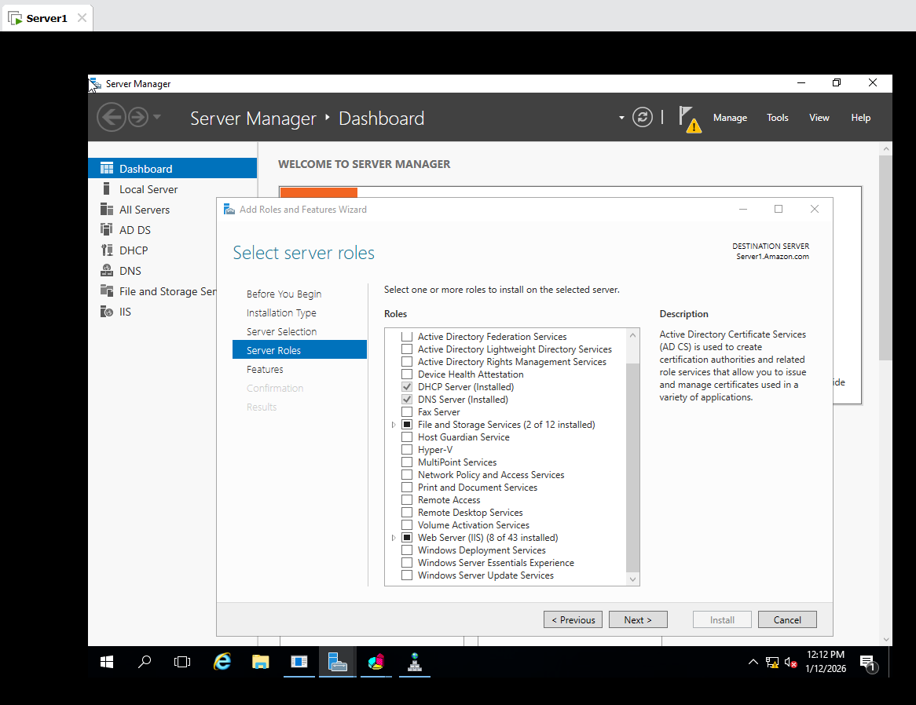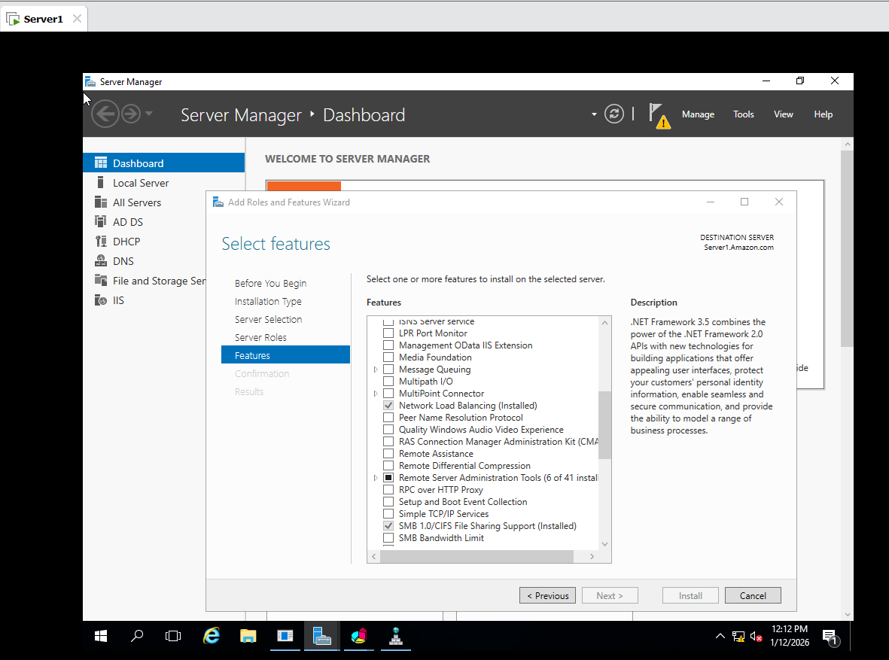
- This same Service is Install on Server2

3.In server 1 :
- Tools Network Load Balancing Right Click on New Cluster give 192.168.10.1 Priority 1 next Add (IPV4 Address 192.168.10.10 ) next Give Internet name Nextgen.local Multicast next Edit Select Multicast Port next.
- Nextgen.local add host to Cluster Host (server2) next.
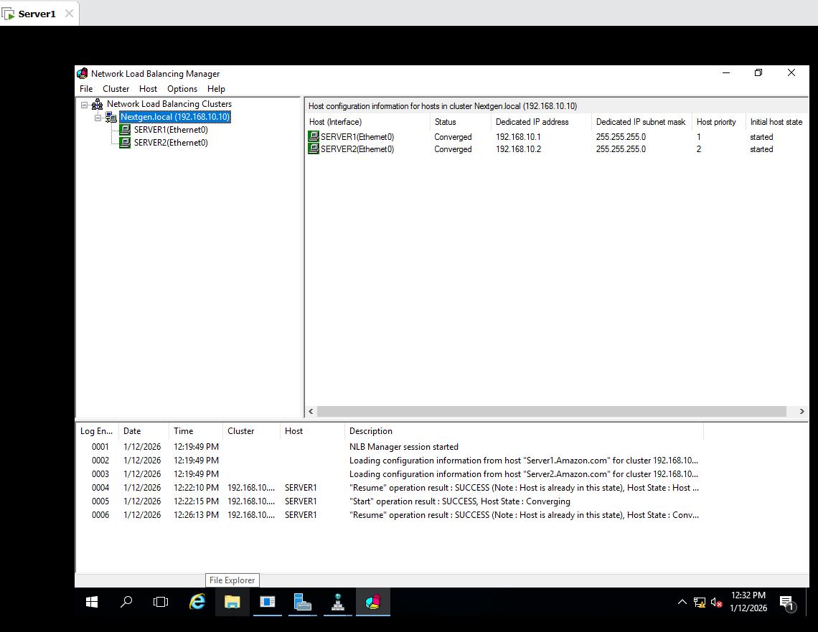
4.In Server1 : Tool DNS Forward Lookup Zone Amazon.com Create A Host give Nextgen give Ip 192.168.10.10.
Check in Server 2 Nextgen Host is created.

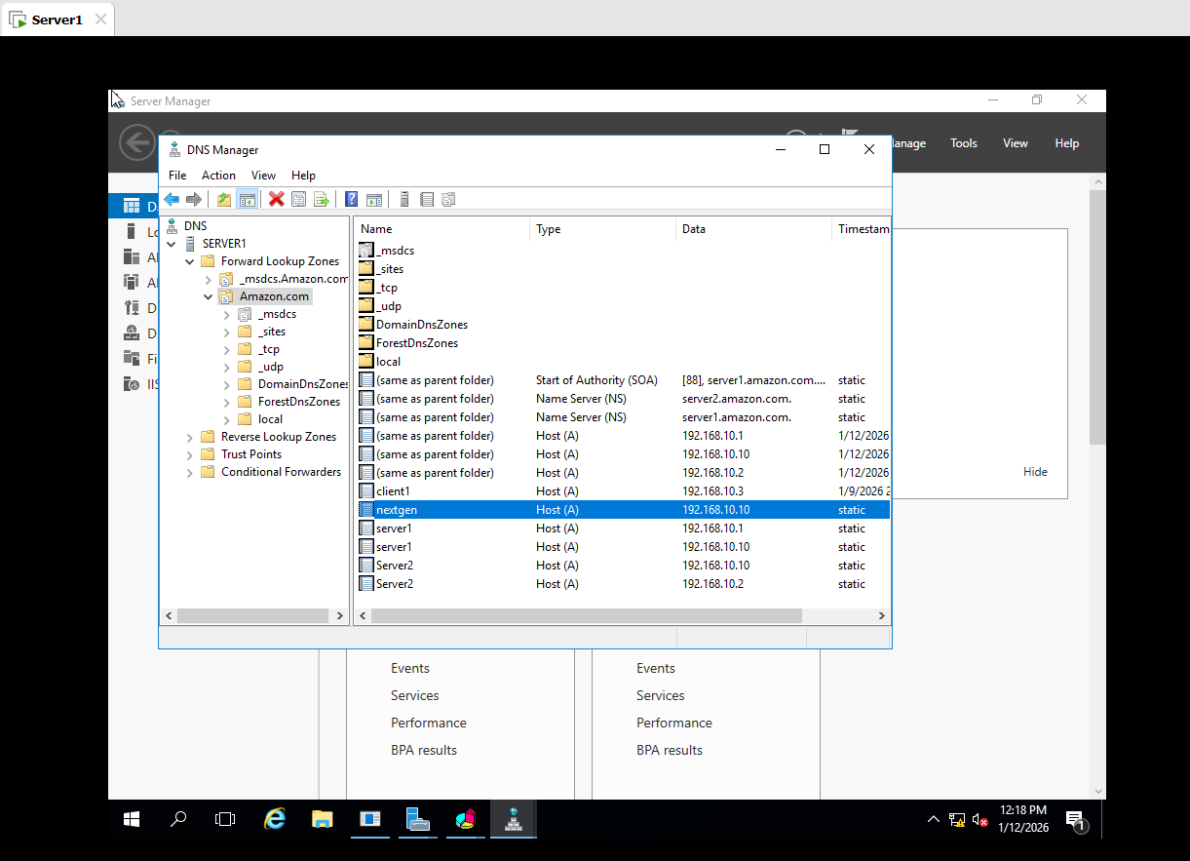
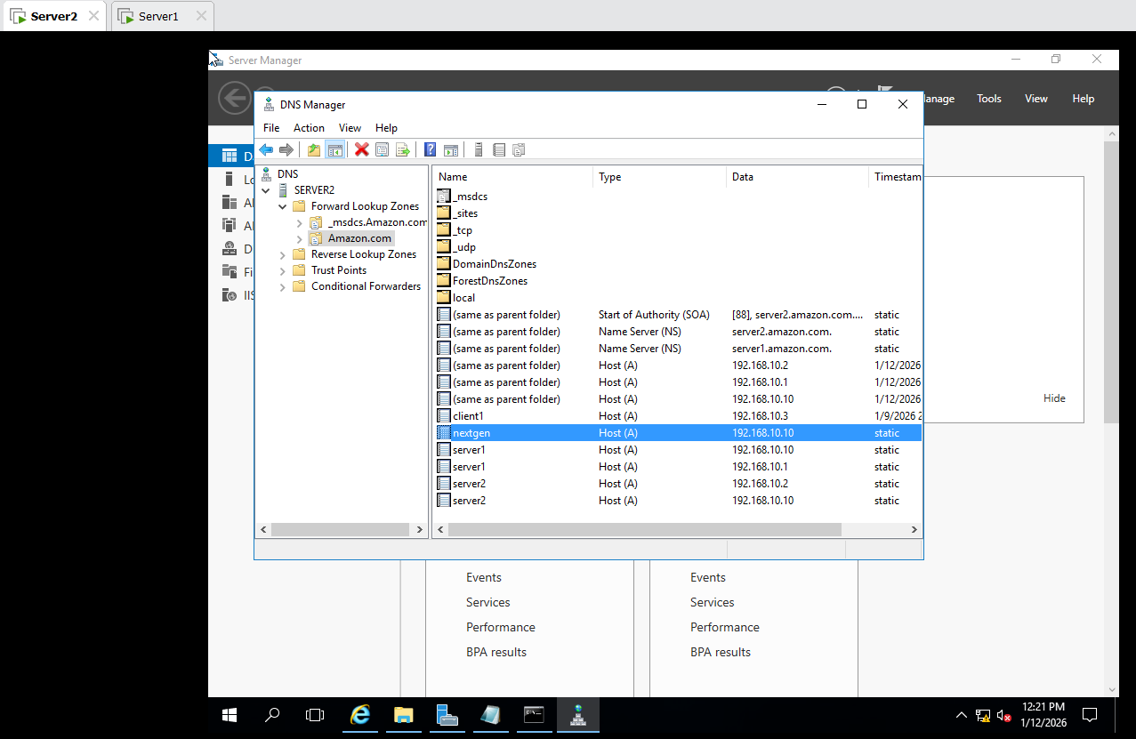
In Server 1 and Server 2 :
This PC C drive inetpub wwwroot Open a Notepad iistart add <P>This is Server 1 ip 192.168.10.1 </p> same for Server 2 iistart file add <P>This is Server 2 ip 192.168.10.2.

In Client 1:
Internet Explore Check http://server1, Check http://server2, Check http://192.168.10.1 , Check http://192.168.10.2
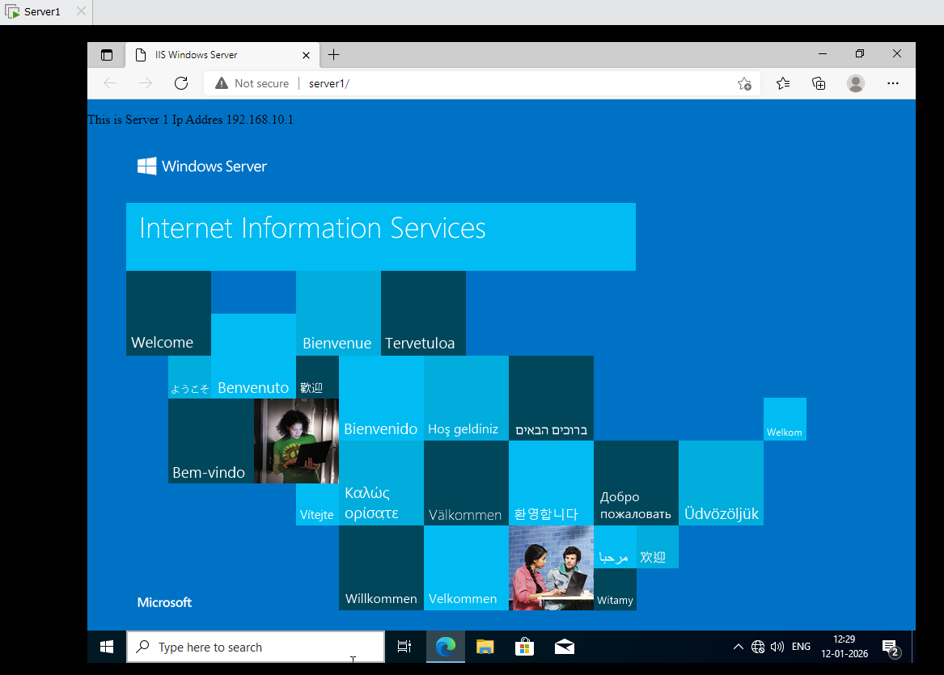
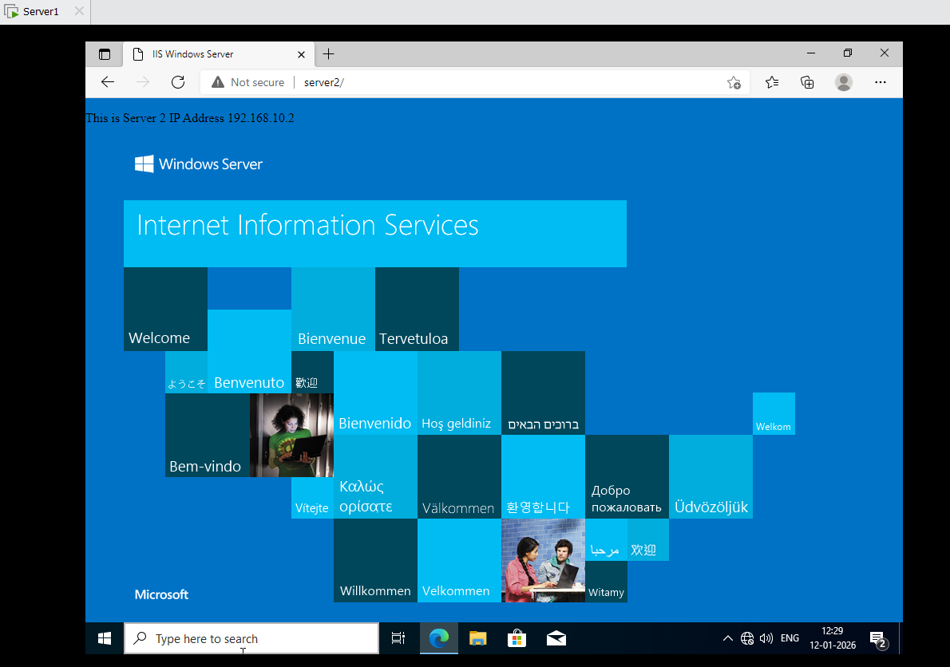
And also check http://nextgen then Show Server1 ip address but Server1 is suspend .
Tool Network Load Balancing Manager Server1 Right Click on Config Host Suspend.
Then Client 1 Internet Explore Check http://nextgen then show Server2 ip address.
Again Server 1 : Tool Network Load Balancing Manager Server1 Right Click on Config Host Resume and Start.

